Supplementary Material

Improved chilling tolerance in glasshouse-grown potted sweet basil by end-of-production, short-duration supplementary far red light
Firdous U. Begum, George Skinner, Sandra P. Smieszek, Simon Budge, Tony D. Stead, Paul F. Devlin*
* Correspondence: Paul F Devlin: Paul.devlin@rhul.ac.uk

Supplementary Figures and Tables

Supplementary Figures

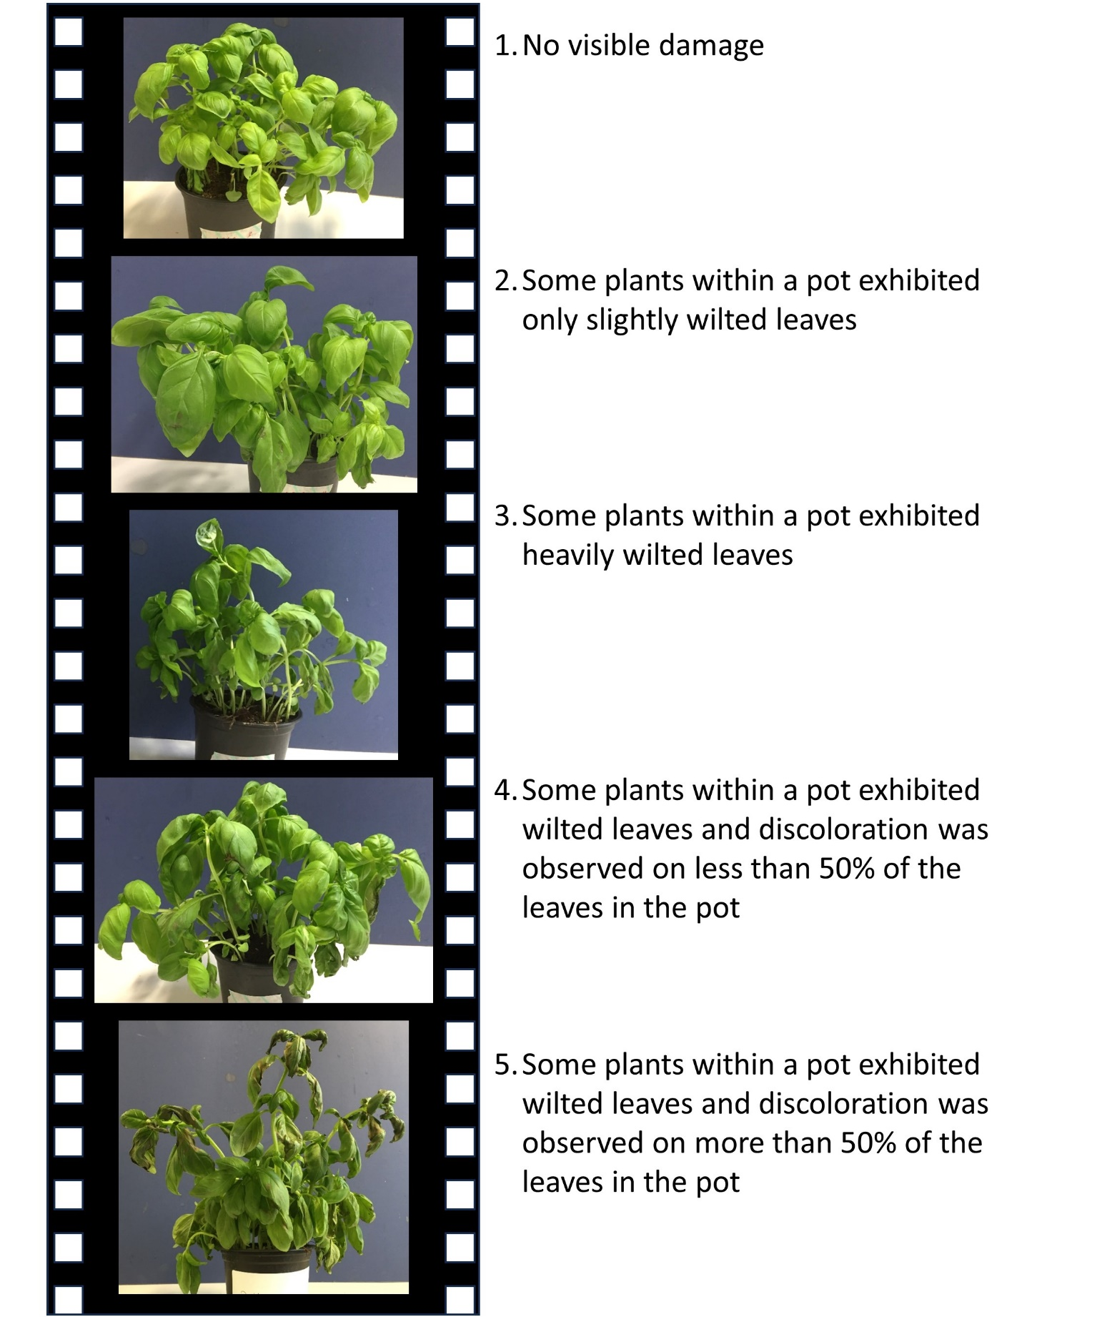

Supplementary Figure 1. Representative pots illustrating the chilling injury scale used in assessing of visible damage after 24 h incubation at 4 ºC. Individual pots were assigned a number as indicated.
A
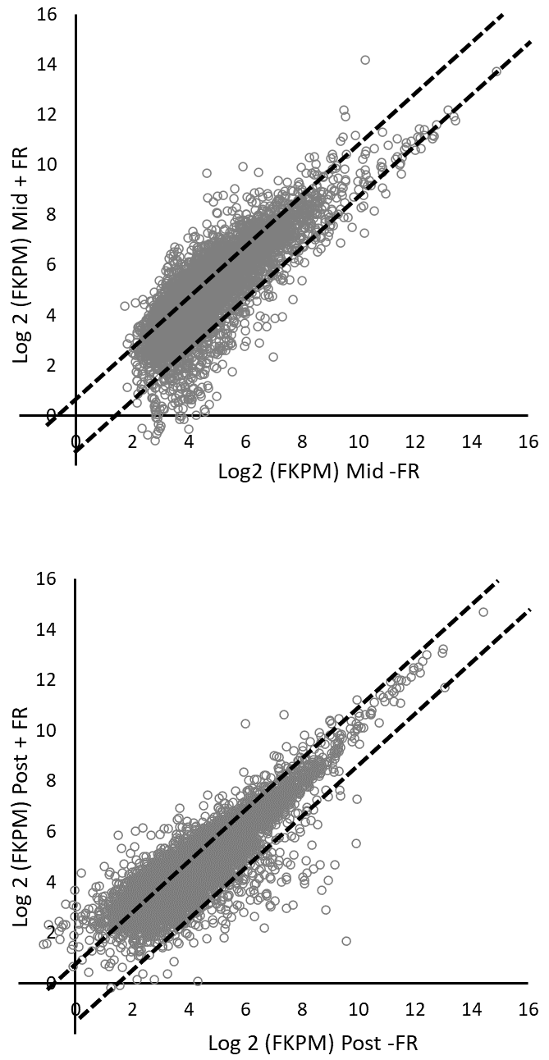
B
Supplementary Figure 2. Global transcript abundances in control versus FR treated plants during (A) and 2 h after (B) supplementary FR treatment. Each point represents a distinct transcript. Transcripts outside of the dotted lines show a two-fold difference in expression compared to control.

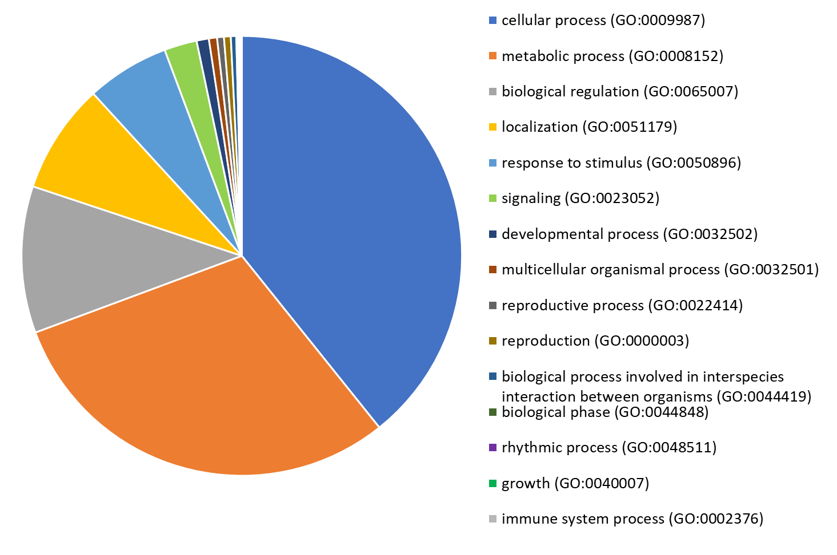
Supplementary Figure 3. Superficial genome-wide gene ontology (GO) analysis cataloging biological processes for all basil transcripts that were mapped to Arabidopsis orthologues.
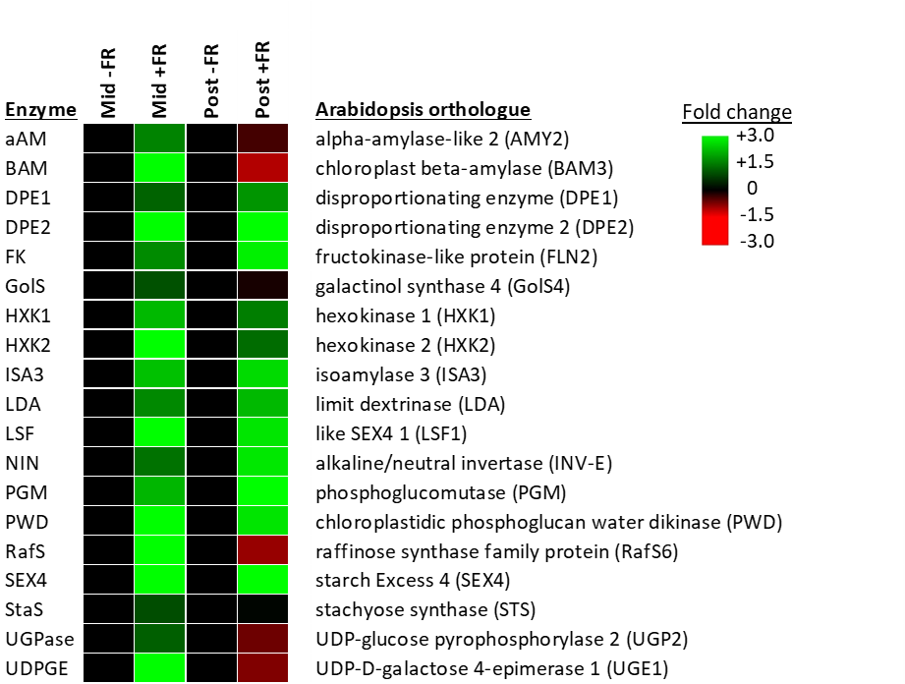
Supplementary Figure 4. Relative expression of genes associated to the GO category, Major CHO Metabolism in control versus FR treated plants during (Mid) and 2 h after (Post) supplementary FR treatment. Enzyme name abbreviations correspond to those in Figure 7 alongside the Arabidopsis orthologues identified for each enzyme in the basil transcriptome.
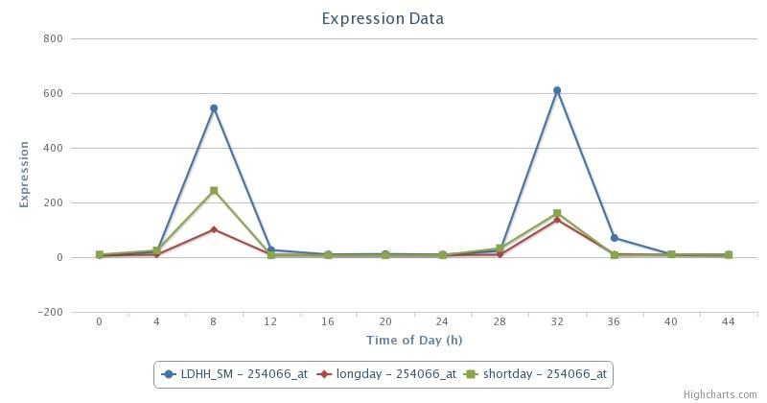Supplementary Figure 5. Relative expression of the CBF3 gene in Arabidopsis in 12 h- (LDHH_SM), 16 h- (longday) and 8 h- (shortday) photoperiods. Figure downloaded from the publicly available Arabidopsis diurnal microarray gene expression database, “Diurnal”, (http://diurnal.mocklerlab.org/). Time of day is measured as hours since dawn on the first of the two days shown.

Supplementary Tables
Supplementary Table 1. Primers used for qRT-PCR confirmation of gene expression.
A. thaliana orthologue | Gene symbol | Basil primer | Sequence
AT4G17090 | BAM3 | Ob-BAM3-F | TGGATTGGCGTTCTTCCTCT
 |  | Ob-BAM3-R | GTCGACGGAACCCAGAGTAT
AT5G20250 | RafS6 | Ob-RafS6-F | CCGCCCAAATTCGTCATCAT
 |  | Ob-RafS6-R | GTTAGTCTCTGCAGCTTGGC
AT1G60470 | GolS4 | Ob-GolS4-F | ACACTGGGGAGGAAGCTAAC
 |  | Ob-GolS4-R | CCCACCATTTCTTCACCAGC
AT4G29130 | HXK1 | Ob-HXK1-F | GGACAAGATGTGGTGGGAGA
 |  | Ob-HXK1-R | ACGTGCATATCAAGGCCAAC
AT1G70820 | PGM | Ob-PGM-F | GAGAAAGGGAGGACGGTGAA
 |  | Ob-PGM-R | TTGGGTCCCTTCCTAACGAC
AT4G01970 | STS | Ob-STS-F | AACACAACCTCCCCTCCATT
 |  | Ob-STS-R | TCAACAGTGGAGGGACGATC
AT5G17310 | UGP2 | Ob-UGP2-F | AGCTCAACATGTCGAGTGGA
 |  | Ob-UGP2-R | TTTGGTCTCAGCGGGATCTT
n/a | UBQ | Ob-UBQ-F | ATTGGAGGTGGAGAGTTCGG
 |  | Ob-UBQ-R | CCTTCCATCCTCCAACTGCT

